Defect Generation Using Stable Diffusion

- Motivation:
Before starting my Master’s degree, I worked as a Computer Vision Engineer at an AI start-up developing automated defect inspection systems. Our work involved building models for defect classification and controlling peripherals to remove defective products from production lines. Like most AI applications, these systems require large amounts of high-quality training data. However, collecting and manually creating defect samples was often time-consuming and labor-intensive. Motivated by this challenge, I aim to develop an AI model capable of generating realistic synthetic defects from only a few defect samples.

- Dataset:
MVTec AD [1] dataset consists of samples for industrial inspection. It contains 5000 images of 15 different objects, each with various kinds of defects.

 | 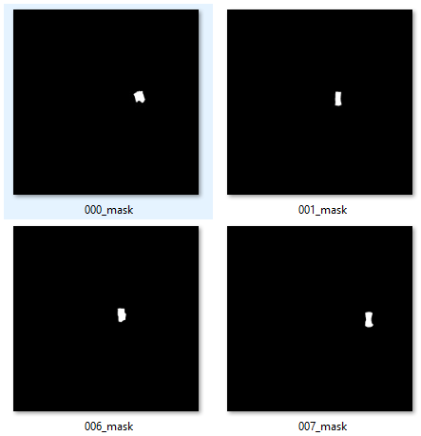
(a) | (b)
Figure 1. (a) Sample images from MVTec AD dataset (b) Defects’ masks.

Most importantly, the dataset already provides defect masks, which are essential for indicating the locations of defects in the reference images and guiding the model on where to place generated defects on defect-free images.

- Approach:
For this assignment, I will implement the approach suggested by Jaewoo Song, et.al [2]. Their method fine-tunes a pre-trained inpainting diffusion model using a small number of defect examples. Once trained, it can take a normal, defect-free product image and insert a new defect to any location.

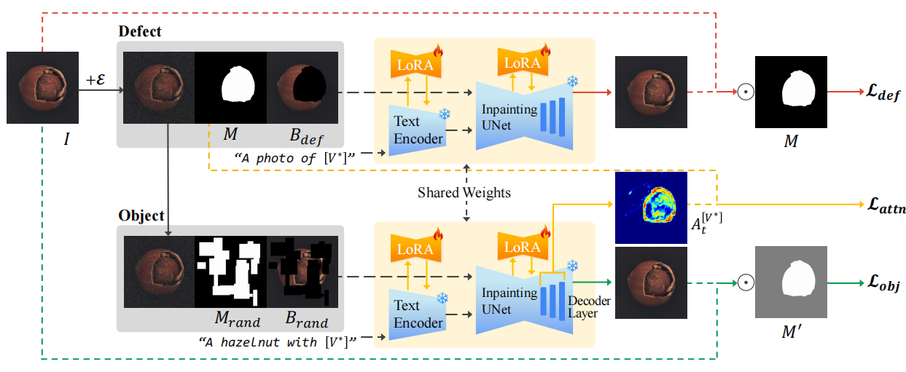
Figure 2. Defect Fill model’s architecture.
This approach reduces training time by applying Low-Rank Adaptation (LoRA) to fine-tune only the text encoder and attention layers of a pre-trained inpainting diffusion model, rather than retraining the entire network.

There are three custom loss functions guiding the training:
- Defect loss: captures the fine details of the defect itself
- Object loss: ensures the defect blends naturally with the surrounding object
- Attention loss: makes sure the model focuses on the correct defect region

One related approach is the Defect-Aware Feature Manipulation GAN [3], which can generate diverse defect patterns but often produces lower-quality results compared to DefectFill. Another diffusion-based method proposed by Ruyi Xu et al. [4] is particularly interesting because it does not require any training. However, the method is considerably more complex, and due to time constraints, I believe it would be difficult to investigate and implement within the scope of this assignment.

- References

- P. Bergmann, M. Fauser, D. Sattlegger, and C. Steger, “MVTec AD—A Comprehensive Real-World Dataset for Unsupervised Anomaly Detection,” in Proceedings of the IEEE/CVF Conference on Computer Vision and Pattern Recognition (CVPR), 2019, pp. 9592–9600.

- J. Song, D. Park, K. Baek, S. Lee, J. Choi, E. Kim, and S. Yoon, “DefectFill: Realistic Defect Generation with Inpainting Diffusion Model for Visual Inspection,” arXiv preprint arXiv:2503.13985, 2025.

- Y. Duan, Y. Hong, L. Niu, and L. Zhang, “Few-Shot Defect Image Generation via Defect-Aware Feature Manipulation,” arXiv preprint arXiv:2303.02389, 2023.

- R. Xu, Y.-T. Chiu, T.-I. Chen, O. Chew, Y.-Y. Chuang, and W.-H. Cheng, “Training-Free Industrial Defect Generation with Diffusion Models,” 2024.

